Jennifer D. Smith

February 26, 2020

Foundations of Programming: Python

Assignment 06

The To-Do List, with Classes and Functions

# Introduction

This week we expanded on the concept of Separation of Concerns with the introduction of classes and functions. We also increased use of GitHub and introduced GitHub Pages.

# Re-building a To Do List based on a someone else's code

First, I added and reworked code that I already had, and tested each segment. Figure 1 shows my first step where I confirmed that I was getting data from the file (without even cleaning up the key names).

Figure Loading the data file with a test statement & confirmation that it worked

Figure 2 Printing out the data we loaded into memory

Figure 3 Add new tasks, ugly confirmation

Figure 4 Remove tasks, but endlessly

Figure 5 Save to file

Figure 6 Exit confirmation

Figure 7 Improved presentation of data

Figure 8 Improved presentation of data

Figure 9 A way out of removing tasks

Figure 10 Improved feedback and an error message

Figure 11 The hazards of working from someone else's file

Figure 12 CRLF

Figure 12 LF makes it better

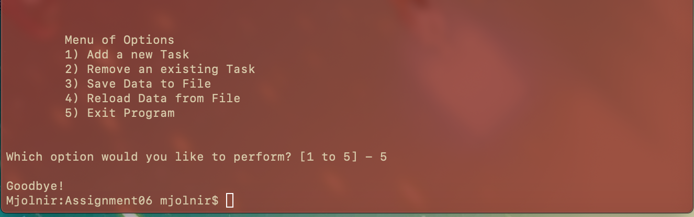

Figure 13 Options 1 - 5 and an error message

# Conclusion

GitHub: <https://github.com/greeneyedsoandso/IntroToProg-Python/blob/master/Assignment05.py>

GitHub Page: <https://greeneyedsoandso.github.io/IntroToProg-Python-Mod06/>